

|  |  |  |  |  |  |  |  |
| --- | --- | --- | --- | --- | --- | --- | --- |
| **NAME** |  | |  | | |  | |
| **SUBJECT** | **SOCIAL STUDIES** | **CLASS** | | **JSS 1** | **DURATION** | | **2HOURS** |

SECTION A

OBJECTIVE [50 MARKS]

INSTRUCTION: ANSWER ALL QUESTIONS IN THIS SECTION

1. 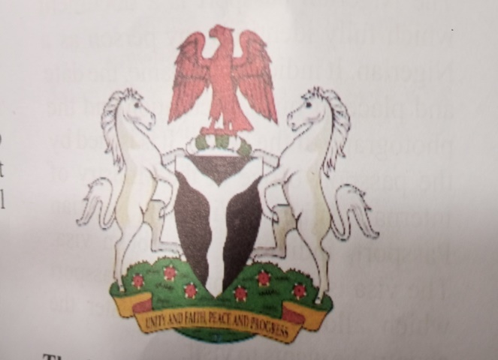

The diagram above is the __

1. Nigerian National Symbols
2. National International Passport
3. Nugaria National Symbol
4. Nupe National Symbol

1. All these are situation that require negotiation except
2. Number of children to have
3. Whether to use contraceptives
4. To have or not to have sexual intercourse
5. The club to join
6. HIV stands for
7. Human Immuno Deficiency Vector
8. Human Immuno Deficiency Virus
9. Higher Immuno Deficiency Virus
10. Higher Immuno Deficiency Vector
11. All these are causes of HIV/AIDS except
12. Unprotected sex
13. Infected blood transfusion
14. Eating with infected person
15. Sharing of sharp objects
16. All these are signs & symptoms of AIDS except
17. Unexplained rapid weight loss
18. Persistent & recurrent fever that last for more than one month
19. Chronic or intermittent diarrhea
20. None of the above
21. Problems of HIV/AIDS include the following except
22. It leads to broken home
23. Loss of human resources
24. Problems of discrimination
25. None of the above
26. How can we prevent HIV/AIDS ?
27. Abstain from sex
28. Use only screened blood
29. Avoid sharing sharp objects
30. All of the above
31. The manipulation of examination process by the candidates , supervisor or invigilator is known as
32. Electoral malpractices
33. Examination malpractices
34. Cultism
35. Laziness
36. The instrument below is used for ___

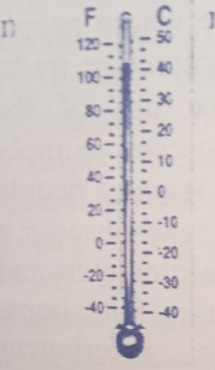

1. Measuring wind
2. Measuring direction
3. Measuring temperature
4. Measuring table
5. All these are examples of examination malpractices except
6. laziness
7. inadequate prepration
8. low self- esteem
9. none of the above
10. Which of these is not among the consequences of examination malpractices ?
11. Dismissal from school
12. Imprisonment of culprit
13. It encourages laziness in student
14. It reduces the cost of conducting examination
15. All these are causes of cultism except
16. Peer group influence
17. Home background
18. Exposure to foreign value
19. None of the above
20. The effect of cultism are
21. Violence
22. Breakdown of social values
23. Criminal tendencies
24. All of the above
25. To curb the menace of cultism in our school , the following steps should be taken except
26. There should be clear & bold billboard warning against cultism in our institutions
27. School authority should be given full authority to dismiss any students or lecturer found to be cult member
28. Parents/ guardians should teach their children moral values
29. Powerful & influential people supporting cultism should be arrested
30. Good negotiation cannot enhance relationship
31. True
32. False
33. Not true
34. Sometimes false
35. People need negotiation when going on a date
36. True
37. False
38. Sometimes true
39. Occasionally false
40. Negotiation exposes one to danger
41. False
42. True
43. All of the above
44. Sometimes false
45. 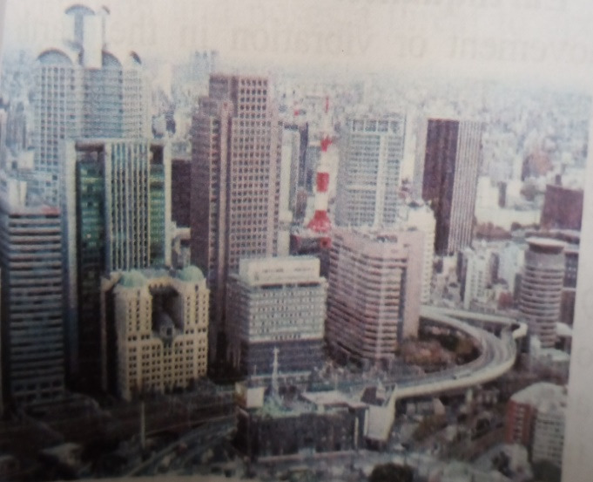

This is an example of ___

1. Rural settlement
2. Urban settlement
3. Castle settlement
4. Cloud settlement
5. All these are skills require in negotiation except
6. Good communication
7. Listening
8. Fighting
9. Use of positive body language
10. The diagram below is used to ___

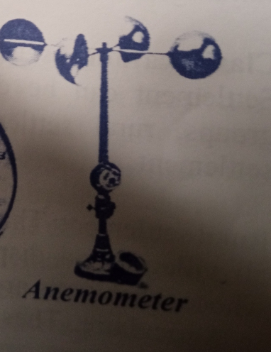

1. Measure wind direction
2. Measure wind speed
3. Measure speed direction
4. Measure temperature
5. Which of these situation may not require Negotiation ?
6. Types of parties to attend
7. Types of food to eat
8. Numbers of children to have
9. None of the above
10. All these are factors that enhances negotiation except
11. Communication
12. Discussion
13. Tolerance
14. None of the above
15. Advantages of negotiation include all these except
16. It promotes tolerance
17. It promotes self- respect
18. It enhances personal development
19. It encourages child - abuse
20. Which of these is not among the Nigeria National Symbols?
21. The coat of arms
22. The National Anthem
23. The National Flag
24. The Nigerian Army
25. The white colour in the Nigeria National flag represent
26. People
27. Development
28. purity
29. agriculture
30. The horse in the Nigeria Coat Of Arms represent
31. National strength & pride
32. National dignity
33. National peace & love
34. Unity & faith
35. The National pledge emphasized the following except
36. Insincerity
37. Honesty
38. Loyalty
39. Faithfulness
40. The silver in the Nigeria coat of arms represent two important river ___ & _____
41. Congo & Zambesi
42. Nile & Jordan
43. Niger & Benue
44. Ose & Osun
45. Who composed Nigeria’s Old National Anthem?
46. Miss Angela Gold
47. Miss I.J William
48. Miss F . Benda
49. Mary Slessor
50. Who wrote the new National Anthem?
51. Prof . Akin Euba
52. Emmanuel Odaise
53. Taiwo Akinkunmi
54. Mr Ugochukwu Daniel
55. When did the new National Anthem replace the old ones ?
56. 1st Oct 1978
57. 1st Oct 1979
58. 1st Oct 1980
59. 1st Oct 1981
60. How can individuals & groups promote National Unity ?
61. Through discrimination
62. Through tolerance
63. Through Non-adherence to peace effort
64. None of the above
65. All these are institutions that can promote National unity except
66. The federal character commission
67. The unity school
68. The National Youth Service Corps
69. Constitution
70. ……. Is made up of the natural & man –made features which can be seen & felt around us
71. Physical environment
72. Social environment
73. Natural environment
74. Mineral resources
75. Physical environment can be divided into …..& …….. features
76. Artificial & natural
77. Physical & social
78. Mineral & resources
79. Present & past
80. All these are man – made features except
81. House
82. Hills
83. Towns
84. Roads
85. Which of these is not a natural feature ?
86. Vegetation
87. Road
88. Valley
89. Lowland
90. Which of these factors does not influence the activities of man in an area ?
91. Climate
92. Relief
93. Road
94. Vegetation
95. A piece of water surrounded by land is called
96. Lake
97. Valley
98. Hill
99. Island land
100. 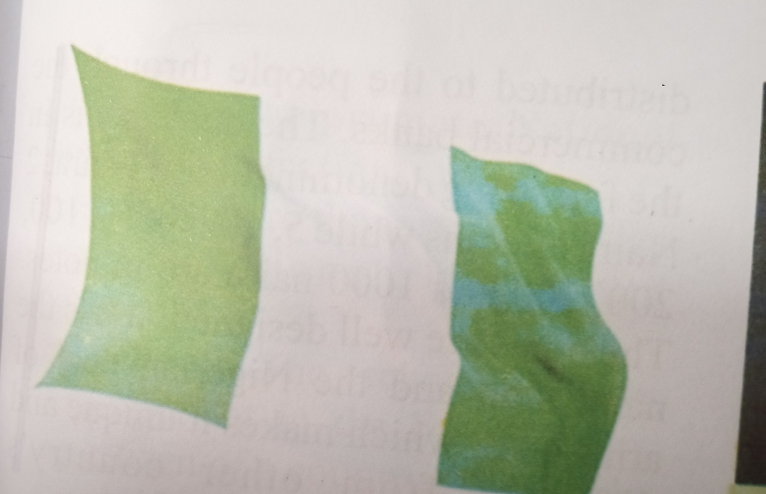

The diagram above represent the ___

1. Confluence town
2. Nigerian National Symbol
3. Book symbols
4. Night National Symbol
5. A place where rivers enter the sea with many mouths is called …..
6. Delta
7. Estuary
8. Island
9. Valley
10. …….. is a place where people settle for the purpose of safety , protection , trade or farming
11. Village
12. farm
13. town
14. settlement
15. All these are a factors that determine the settlement pattern of an area except
16. Closeness to the market
17. Closeness to the people
18. Availability of fertile soil for farming
19. Closeness to power supply
20. Settlement can be divided into two . These are
21. Village & hamlet
22. Rural & urban
23. Town & city
24. Homestead & village
25. Which of these is not among the type of settlement ?
26. Dispersed settlement
27. Linear settlement
28. Partially dispersed settlement
29. Triangular settlement
30. …… is the way in which the surface of the land is formed
31. The relief of an area
32. Natural resources
33. Geography
34. Settlement
35. …….. are called the free gift of nature
36. Settlement
37. Relief
38. Natural resources
39. Physical environment
40. Which of the following minerals is mined in Jos ?

A. Copper

B. Iron-ore

C. Gold

D. Coal

1. Natural resources includes all of the following except

A. Building

B. Vegetation

C. Mineral

D. Oceans

1. Coal is mined in …….

A. Jos

B. Enugu

C. Lokoja

D. Sokoto

**SECTION B- THEORY**

***Answer only* four *questions from this part [40 marks]***

1. (a) What is **national unity ?**  [1mark]

(b) Mention four institutions that promote national unity [4 marks]

(c) Give five Nigerian national symbols [5 marks]

2 . (a) Define Cultism [1 mark]

(b) List 10 causes of cultism [5marks]

(c) State four consequences of cultism [4 marks]

3. (a) What is examination malpractices [2marks]

(b) Identify four ways of preventing examination malpractices [4marks]

(c)Mention four consequences of examination malpractices [4marks]

4. (a) Define Negotiation [1mark]

(b)Mention six factors that enhance negotiation [3marks]

(c)State four advantages of negotiation [4marks]

(d)Explain Negotiation techniques [2marks]

5. (a) What is the full meaning of HIV/AIDS [2marks]

(b). Mention four effects of STI [4marks]

( c.) State four ways of preventing HIV /AIDS [4marks]